Financial reasons - analysis of liquidity and activity of a company

Instructions:

Answer the following exercises:
Exercise 7-4: Financial Ratio
Exercise 7-6: Financial Ratio
Problem 7-1: Liquidity Ratio
Problem 7-4: ROE

Exercise 7-4: Financial Ratio
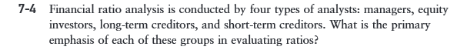

Exercise 7-6: Financial Ratio
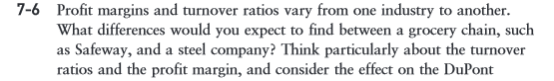

Problem 7-1: Liquidity Ratio
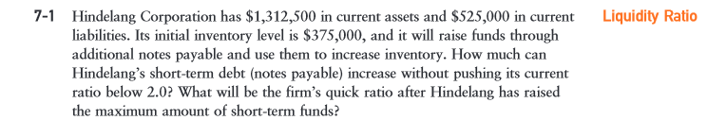

Problem 7-4: ROE
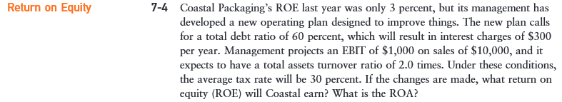

General instructions:
- Use MS Word or MS Excel to do the exercises.
- You must show the computes of each exercise to be able to evaluate all the steps that you followed to reach the final result. If you do not show the calculations, you will not accumulate the total of the points.

